Encoder

Decoder

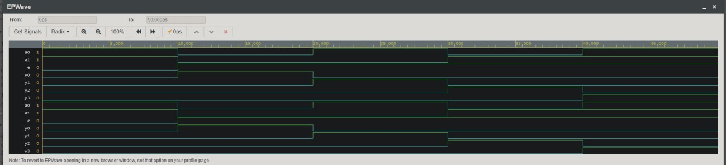

Mux

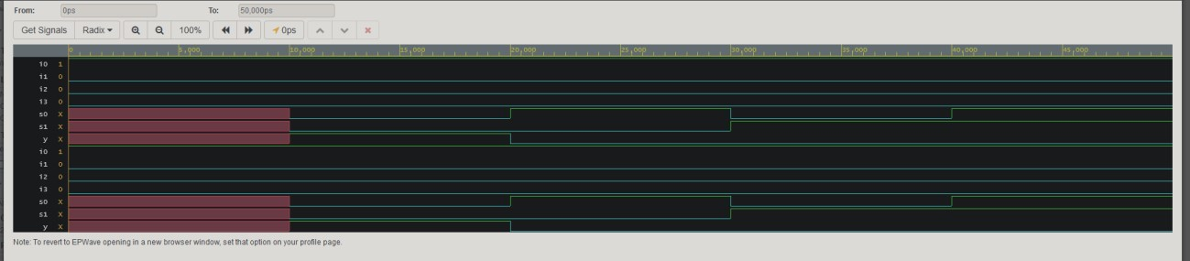

Demux

